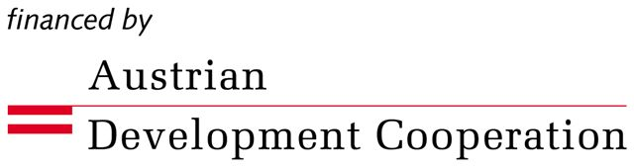
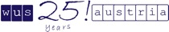

INNOVATIVE PROJECT IDEAS

IN THE FIELD OF ACADEMIC COOPERATION AND EXCHANGE

BETWEEN AUSTRIAN AND MONTENEGRIN

HIGHER EDUCATION INSTITUTIONS

INSTRUCTIONS

Please read carefully!

The Innovative Project Ideas in the Field of Academic Cooperation and Exchange between Austrian and Montenegrin Higher Education Institutions will enhance the exchange of students, professors and assistants between the University of Montenegro and Austrian HE institutions. The project is open to all faculties of the University of Montenegro and all Austrian universities.

Aims of the project:

- To enable and support academic mobility for the mentioned target groups between Austria and Montenegro
- To contribute to teaching and curriculum development, development of modern and innovative teaching methodologies and materials
- To contribute to sustainable institutional cooperation through contacts that are made within this project
- To enable exchange of experiences and transfer of knowledge in both directions

WUS Austria supports the following:

- Travel costs (including train, bus or plane tickets) up to EUR 800 per person.
- Monthly allowance (accommodation and per diem) up to EUR 1 200 per month (max. 30 days).

WUS Austria provides funds for the above items before the study visit. On completion of a study visit applicants should provide WUS Austria with the original receipts for accommodation and travel tickets with boarding passes. After the completion of a project, the recipients need to write a final narrative report as well as to submit student evaluations. Forms will be provided by WUS Austria.

The projects are to be completed until November 2010.

Must criteria:
-Quality of application
- Partner institution from Austria/MNE
- Coordinator’s CV
- At least one professor or assistant from each participating institution
- Student involvement (The minimum of 3 participants: one professor/assistant + two students from each participating institution).

Assets:
- Mobility in both directions (Austrian group to Montenegro and vice versa)
- Level of innovation
- Quality and scope of cooperation with the Austrian HE institution
- Projects which include mutual ECTS recognition
- Projects co-financed by the participating institutions or other co-donors
- Sustainability of the project
- Multiplier effect

The decision will be made by a Selection Committee consisting of the representatives of the Austrian Development Cooperation as the donor, University of Montenegro as the Beneficiary and WUS Austria as the implementing agency. No recourse to legal action will be permitted.
Please submit your application together with the CV of the coordinator to the WUS office in Podgorica and email the electronic version to: ivana.zivaljevic@wus-austria.org.
Submission deadline: September 30th 2009. Incomplete applications as well as requests for retroactive support will not be considered!

As an equal opportunity organization, WUS Austria strongly supports female candidates to apply.

Further enquiries should exclusively be in written form and addressed to:

Ivana Živaljević
Coordinator for the Innovative Project Ideas

ivana.zivaljevic@wus-austria.org

WUS Austria Podgorica Office
Dzordza Vasingtona bb
(zgrada Tehničkih fakulteta)
PO Box 21, 81000 Podgorica
Phone/fax: +382 20 245 007
www.wus-austria.org

